Single Page Applications (SPA) and Blazor as a SPA framework in the .NET ecosystem.

1. Overview of Single Page Applications (SPA)
What is a SPA?
A Single Page Application (SPA) is a web application that loads a single HTML page once and then dynamically updates the content as the user interacts with the app—without full page reloads.
Instead of navigating between multiple HTML pages, the browser:
- Loads the app shell (HTML + CSS + JavaScript)
- Fetches data asynchronously (usually via APIs)
- Updates the UI dynamically using client-side logic

Traditional Web App vs SPA
Aspect | Traditional Web App | SPA
Page Load | Full page reload per request | Single initial load
UI Updates | Server-rendered HTML | Client-side rendering
Navigation | Browser refresh | Client-side routing
Performance | Slower after interactions | Faster, smoother UX
Backend | MVC / Razor Pages | API-based (REST/GraphQL)

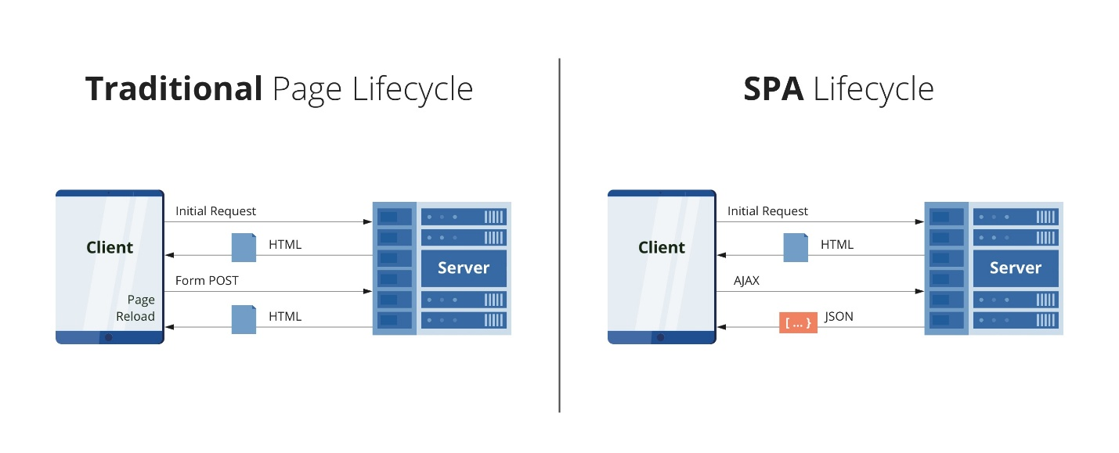

Core Characteristics of SPA
- Client-Side Routing
  - URL changes without reloading the page
  - Navigation handled inside the browser
- Asynchronous Communication
  - Uses AJAX / Fetch / HTTP APIs
  - Data exchanged as JSON
- Stateful UI
  - UI state managed in the client
  - Components re-render when state changes
- Rich User Experience
  - Fast interactions
  - Desktop-like feel

Popular SPA Frameworks
- Angular
- React
- Vue
- Blazor (C#-based SPA framework)

2. Blazor as a Single Page Application Framework
What is Blazor?
Blazor is a modern SPA framework from Microsoft that allows developers to build interactive web UIs using C# and .NET instead of JavaScript.
Blazor enables SPA development by:
- Using components
- Supporting client-side routing
- Managing UI state
- Communicating with backend APIs asynchronously

Why Blazor is Considered a SPA
Blazor satisfies all SPA principles:
SPA Principle | How Blazor Implements It
Single Page Load | Loads once, updates dynamically
Client-Side Routing | @page directive + Router
Dynamic UI Updates | Component re-rendering
API Communication | HttpClient
State Management | Scoped/Singleton services

3. Blazor SPA Architecture
High-Level Architecture
Browser
├── Blazor App (Components)
│ ├── Razor Components (.razor)
│ ├── Routing & Navigation
│ ├── State Management
│
├── API Calls (HTTP / gRPC)
│
Backend (ASP.NET Core)
├── Web API / Minimal API
├── Authentication / Authorization
└── Database

4. Blazor Hosting Models and SPA Behavior
1. Blazor WebAssembly (Client-Side SPA)
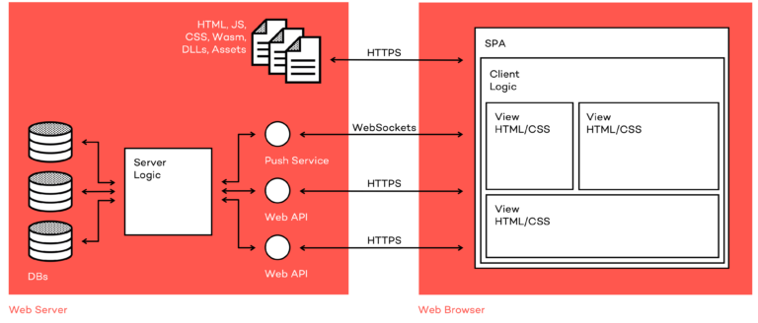

- Runs entirely in the browser
- .NET runtime runs on WebAssembly
- Communicates with backend APIs
- Closest to React/Angular SPA model
Key SPA Traits
- Offline capability
- Reduced server load
- Rich client-side interactivity

2. Blazor Server (Server-Driven SPA)
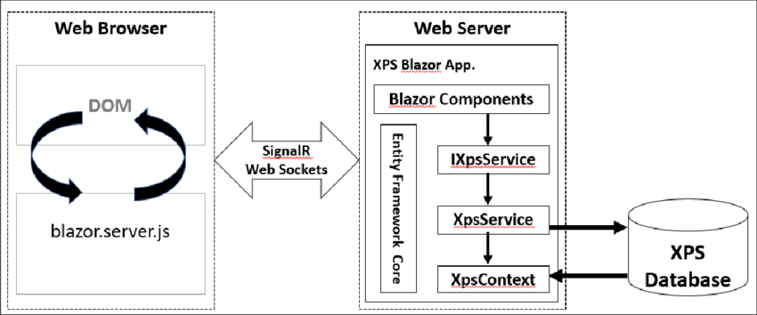

- UI logic runs on the server
- Browser maintains a SignalR connection
- DOM updates are streamed to the client
Still a SPA because
- No full page reloads
- Client-side routing
- Stateful UI over a persistent connection
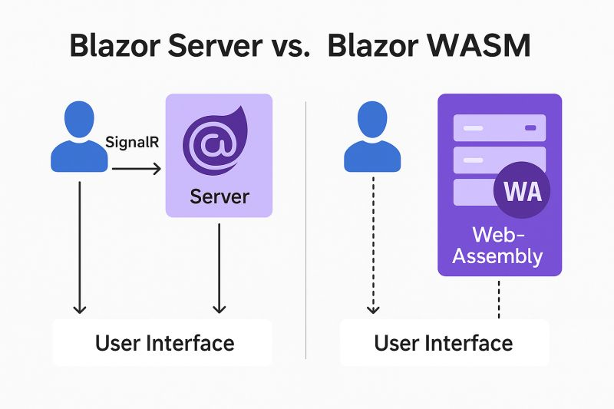

5. Blazor Component Model (SPA Core Concept)
Components are the Building Blocks
@page "/counter"

<h3>Counter</h3>

<p>Current count: @count</p>

<button @onclick="Increment">Click me</button>

@code {
int count = 0;

void Increment()
{
count++;
}
}
SPA Behavior
- UI updates instantly
- No page refresh
- State-driven rendering

6. Advantages of Blazor as a SPA Framework
Technical Benefits
- Single language: C# for frontend + backend
- Strong typing & compile-time checks
- Shared models between UI and API
- First-class .NET tooling
Enterprise Benefits
- Ideal for line-of-business applications
- Long-term maintainability
- Easier onboarding for .NET teams

7. When to Use Blazor as a SPA
Best Fit Scenarios
- Enterprise dashboards
- Admin portals
- Internal business applications
- Teams with strong .NET background

8. Summary
SPA
- A web app model with single-page loading and dynamic updates
Blazor as a SPA
- Fully compliant SPA framework
- Uses C# and .NET instead of JavaScript
- Supports both client-side and server-driven SPA models

